National Conference on Recent Trends in Communication, Computing and IoT 2022

Click here, type the title of your paper, Capitalize first letter
First Authorª, Second Author^{b}, Third Author^{a,b,}*
*indicate corresponding author
ªFirst affiliation, Address, City and Postcode, Country
^{b}Second affiliation, Address, City and Postcode, Country

Abstract

Click here and insert your abstract text (words must be equal to or less than 250-300).

Keywords: Type your keywords here, separated by semicolons ;( maximum 5 keywords)

Introduction

(10 pt) Here introduce the paper, and put a nomenclature if necessary, in a box with the same font size as the rest of the paper. The paragraphs continue from here and are only separated by headings, subheadings, images and formulae. The section headings are arranged by numbers, bold and 10 pt. Here follows further instructions for authors.

Structure

For this Procedia the files must be in MS Word format only and should be formatted for direct printing. Figures and tables should be embedded and not supplied separately. Please make sure that you use as much as possible normal fonts in your documents. Special fonts, such as fonts used in the Far East (Japanese, Chinese, Korean, etc.) may cause problems during processing. To avoid unnecessary errors you are strongly advised to use the „spellchecker‟ function of MS Word. Follow this order when typing manuscripts: Title, Authors, Affiliations, Abstract, Keywords, Main text (including figures and tables), Acknowledgements, References, Appendix. Collate acknowledgements in a separate section at the end of the article and do not include them on the title page, as a footnote to the title or otherwise.
Bulleted lists may be included and should look like this:
- First point
- Second point
- And so on
Ensure that you return to the „Els-body-text‟ style, the style that you will mainly be using for large blocks of text, when you have completed your bulleted list.
Please do not alter the formatting and style layouts which have been set up in this template document. As indicated in the template, papers should be prepared in single column format suitable for direct printing onto A4 paper (192mm x 262 mm). Do not number pages on the front, as page numbers will be added separately for the preprints and the Proceedings. Leave a line clear between paragraphs. All the required style templates are provided in this document with the appropriate name supplied, e.g. choose 1. Els1st-order-head for your first order heading text, els-abstract-text for the abstract text etc.

Tables

All tables should be numbered with Arabic numerals. Headings should be placed above tables, center justified. Leave one line space between the heading and the table. Only horizontal lines should be used within a table, to distinguish the column headings from the body of the table, and immediately above and below the table. Tables must be embedded into the text and not supplied separately. Below is an example which authors may find useful.

Table 1. An example of a table

An example of a column heading | Column A (t) | Column B (T)
And an entry | 1 | 2
And another entry | 3 | 4
And another entry | 5 | 6

Construction of references

References should be added at the end of the paper, and its corresponding citation will be added in the order of their appearance in the text. Authors should ensure that every reference in the text appears in the list of references and vice versa. Indicate references by [1], [2] in the text. The actual authors can be referred to, but the reference citation(s) must always be given.
Some examples of how your references should be listed are given at the end of this template in
The References section, which will allow you to assemble your reference list according to the correct format and font size.

Section headings

Section headings should be left justified, with the first letter capitalized and numbered consecutively, starting with the Introduction. Sub-section headings should be in capital and lower-case italic letters, numbered 1.1, 1.2, etc, and left justified, with second and subsequent lines indented. You may need to insert a page break to keep a heading with its text.

General guidelines for the preparation of your text

Avoid hyphenation at the end of a line. Symbols denoting vectors and matrices should be indicated in bold type. Scalar variable names should normally be expressed using italics. Weights and measures should be expressed in SI units. Please title your files in this order conferenceacrynom_authorslastname.pdf

Footnotes

Footnotes should be avoided if possible. Necessary footnotes should be denoted in the text by consecutive superscript letters. The footnotes should be typed single spaced, and in smaller type size (8pt), at the foot of the page in which they are mentioned, and separated from the main text by a short line extending at the foot of the column. The “Els-footnote” style is available in this template for the text of the footnote.

Design/Method/Algorithm

All figures should be numbered with Arabic numerals (1,2,...n). All photographs, schemas, graphs and diagrams are to be referred to as figures. Line drawings should be good quality scans or true electronic output. Low-quality scans are not acceptable. Figures must be embedded into the text and not supplied separately. Lettering and symbols should be clearly defined either in the caption or in a legend provided as part of the figure. Figures should be placed at the top or bottom of a page wherever possible, as close as possible to the first reference to them in the paper.
The figure number and caption should be typed below the illustration in 8pt and center justified. Artwork has no text along the side of it in the main body of the text. However, if two images fit next to each other, these may be placed next to each other to save space, see Figure 1. They must be numbered consecutively, all figures, and all tables respectively.

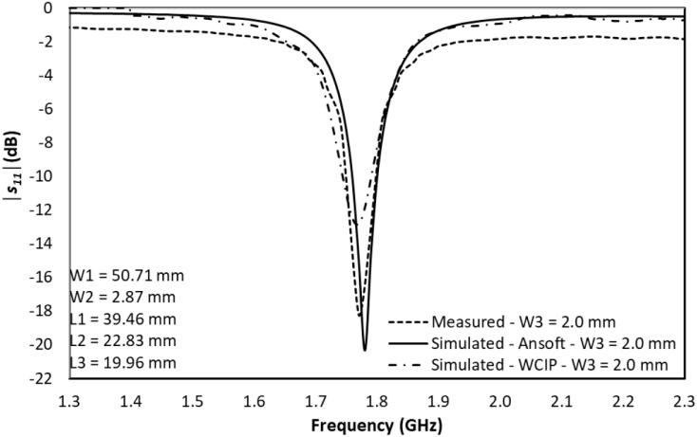

Figure 1. (a) first picture; (b) second picture

Figure 1. Simulated and measured return loss

Equations and formulae should be typed and numbered consecutively with Arabic numerals in parentheses on the right hand side of the page (if referred to explicitly in the text).

(1)
They should also be separated from the surrounding text by one space.

Results & discussion

Explain results here.

Conclusion

Type conclusion here.

Acknowledgements

Type acknowledgement here if any

References
[1] Authors’names, “Title of paper,” title of journal/conference, Vol.No. , Issue No., pp. xxx-yyy, year of publication.
[2] Mandar P. Joshi, Jayant G. Joshi, Shyam S. Pattnaik, “Stub Loaded Rectangular Ring Shaped Tri-Band Monopole Antenna for Wireless Applications,” International Journal of Advances in Microwave Technology, Vol. 5, No. 2, pp. 227 – 233, 2020.
[3] Girish Kumar and K. P. Ray, Broadband Microstrip Antennas, Artech Publishing, 2003.

